 WOODLANDS RING SECONDARY SCHOOL

Name : ____________________________ Reg No. ____ Class : ________

EXAMINATION : END OF YEAR

YEAR : 2009 DATE : 7 OCT

SUBJECT : MATHEMATICS PAPER : 2

LEVEL : SECONDARY ONE EXPRESS

DURATION : 1 hour 15 minutes MAX MARKS : 50

SETTER : Mr Richard Lui

READ THESE INSTRUCTIONS FIRST

- Write your name, class and register number on the cover page.
- Write in dark blue or black pen in the spaces provided on the Question Paper.
- You may use a pencil for any diagrams or graphs.
- Do not use staples, paper clips, highlighters, glue or correction fluid.
- Answer all the questions.
- If working is needed for any question it must be shown in the space below that question.
- Omission of essential working will result in loss of marks.
- You are expected to use a scientific calculator to evaluate explicit numerical expressions.
- If the degree of accuracy is not specified in the question, and if the answer is not exact, give the answer to three significant figures. Give answers in degrees to one decimal place.
- For π, use either your calculator value or 3.142, unless the question requires the answer in terms of π.
- The number of marks is given in brackets [ ] at the end of each question or part question.
For Examiner’s Use
/50

This question paper consists of 9 printed pages, including this cover page.
[Turn over
1. | In the diagram, ABCD is a parallelogram.
 | (i) | Write an expression for the perimeter of ABCD and simplify the expression.
 | (ii) | Given that a = 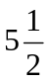 and b = 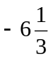, evaluate the perimeter of ABCD.
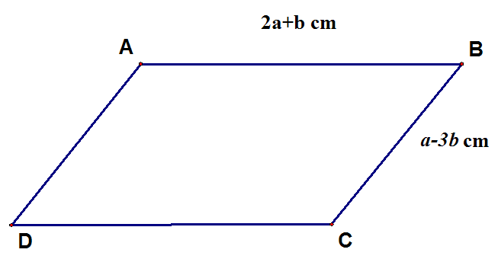
2a + b cm
a − 3b cm
(i) | Perimeter | = 2(2a + b) + 2(a – 3b) | [1]
 |  | = 4a + 2b + 2a – 6b
 |  | = 6a – 4b cm | [1]
(ii) | Perimeter | = 6() – 4()
 |  | = 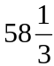 cm | [1]

 | Ans: |  | (i) | cm | [2]
 |  |  | (ii) | cm | [1]
2. | Find two consecutive odd integers such that their sum is 164.
Let x by the smaller number and x + 2 be the larger.
x + x + 2 | = 164 |  | [1]
2x + 2 | = 164
2x | = 162
x | = 81
Integers are 81 and 83. |  | [1]

 | Ans: |  |  |  | [2]

3. | Solve the equation,  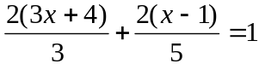
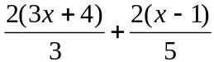 | = 1
10(3x + 4) + 6(x – 1) | = 15 | [1]
30x + 40 + 6x − 6 | = 15 | [1]
36x | = −19 | [1]
x | = 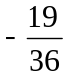 | [1]

 | Ans: |  |  |  | x = |  |  | [4]
4. | A motorist took 2 hours at a speed of 85 km/h to travel from Town A to Town B. At Town B, he rested for 4 hours. He then made his way back to Town A which he took half an hour longer.
 | (a) | Calculate the distance, in km, between Town A and Town B.
1 hr | ➔ | 85 km
2 hrs | ➔ | 170km

 | Ans: |  |  | (a) |  | km |  | [1]
 | (b) | Calculate his speed for the return journey.
2.5 hrs | ➔ | 170 km
1 hr | ➔ | 170 ÷ 2.5
 |  | = 68 km/h

 | Ans: |  |  | (b) |  | km/h |  | [1]
 | (c) | Calculate the average speed for the entire journey.
Average speed | = 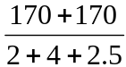 | [1]
 | = 40 km/h | [1]

 | Ans: |  |  | (c) |  | km/h |  | [2]

5. | The marked price of a car is $82 000 without GST. A car dealer gave a 5% discount to a customer. (Take GST to be 7%.)
 | (a) | Calculate the selling price of the car without GST.
100% | ➔ | $82000
95% | ➔ | 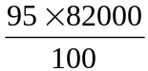 | [1]
 |  | = $77900 | [1]

 | Ans: |  |  |  | (a) |  |  | $ | [2]
 | (b) | Calculate the amount of GST paid by the customer.
GST paid | = 7% × $77900
 | = $5453

 | Ans: |  |  |  | (b) |  |  | $ | [1]
 | (c) | Calculate the percentage change in GST on the marked price and the selling price.
GST for marked price | = 7% × $82000
 | = $5740 | [1]
% decrease in GST | = 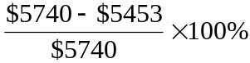 | [1]
 | = 5% | [1]

 | Ans: |  |  | (c) |  |  | % |  | [3]
6. | Two exterior angles of an 8-sided polygon are each 75°, three exterior angles measure 60° each and the remaining exterior angles are x each. Find the value of x.
(2 × 75°) + (3 × 60°) + 3x | = 360° | [1]
3x | = 360° – 330°
x | = 10° | [1]

 | Ans: |  | x = |  |  | ° |  |  | [2]

7. | In the diagram, ABCD is a rhombus where BD is the diagonal, ∠ABC = 110° and ∠BCX = 45°. Find a°, b° and c°. (State your reasons clearly.)  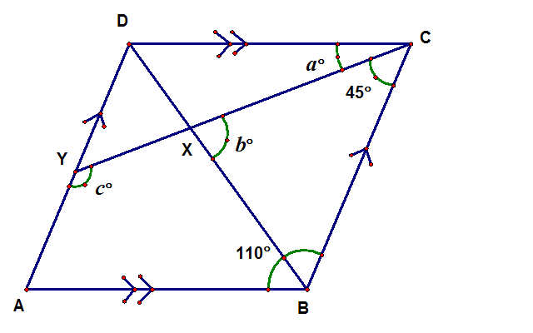
BCX | = 180° - 110° | (int angles, AD//BC)
 | = 70° |  | [1]
a° | = 70° - 45° | (adj angles)
 | = 35° |  | [1]
DBC | = 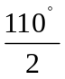 | (diagonals of rhombus bisect angles)
 | = 55° |  | [1]
b° | = 180° - 55° - 45° | (angles sum of a triangle)
 | = 80° |  | [1]
CYD | = 45° | (alt angles, AD//BC) | [1]
c° | = 180° - 45° | (supp. angles)
 | = 135° |  | [1]

 | Ans: | a °= | ° | [2]
 |  | b° = | ° | [2]
 |  | c° = | ° | [2]

8. | In the diagram, ABCD is a trapezium where AB is parallel to DC, AB = 45 cm, DC = 20 cm, AC = 40.5 cm and the height of the trapezium is 10 cm.  40.5 cm  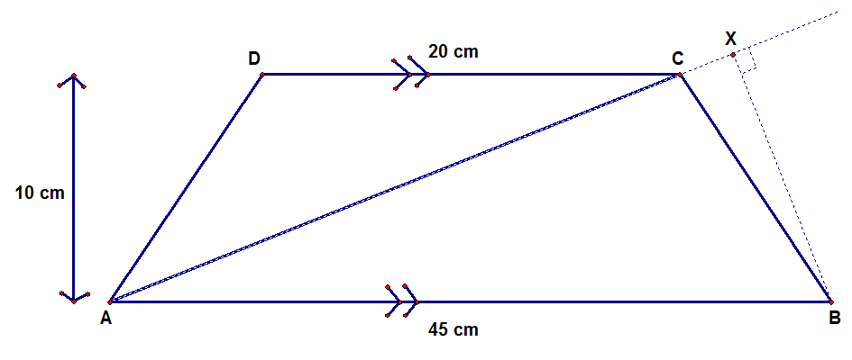
 | (a) | Find the area of the trapezium ABCD.
 | (b) | Find the area of ABC.
 | (c) | Find the length of BX.
(a) | Area of trapezium | = ½ × (20 + 45) × 10 | [1]
 |  | = 325 cm² | [1]
(b) | Area of triangle | = ½ × 45 × 10 | [1]
 |  | = 225 cm² | [1]
(c) | ½ × 40.5 × BX | = 225 | [1]
 | BX | = 450 ÷ 40.5
 |  | = 11.1 cm (3 s.f.) | [1]

 | Ans: |  | (a) | cm² | [2]
 |  |  | (b) | cm² | [2]
 |  |  | (c) | cm | [2]

9. | (a) |  | The figure shows a cross-section of a pendant. IHG is a semicircle,  AB = EF = 3 cm, CD = 2 cm and AI = 6 cm. A goldsmith was asked to create the pendant as shown in the diagram of thickness 1.5 cm. Calculate,
 |  |  | (i) | the area of the figure,
 |  |  | (ii) | the volume of the figure, correct your answers to 2 decimal places.  (Take = 3.14.)
 |  |  | 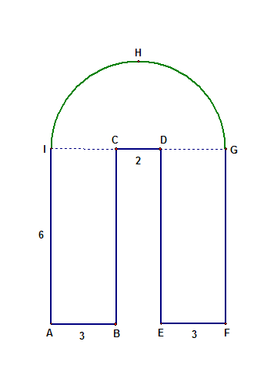
(i) | Area | = (2×6×3) + ½×3.14×4² | [1]
 |  | = 61.12 cm² | [1]
(ii) | Volume | = 61.12 × 1.5 = 91.68 cm³ | [1]

 | Ans: (i) |  |  |  |  | cm² | [2]
 | Ans: (ii) |  |  |  |  | cm³ | [1]
 | (b) |  | The goldsmith has a rectangular gold bar of dimensions 4 cm by 100 cm by 3.14 cm. Find the maximum number of pendants the goldsmith can make from the rectangular gold bar.
Vol. of gold bar | = 4 × 100 × 3.14
 | = 1256 cm³ | [1]
No. of pendants | = 1256 ÷ 91.68
 | ≈ 13 | [1]

 | Ans: |  |  |  | (b) |  | [2]

10. |  | (i) | Construct a line segment AB 10 cm long. |  |  |  | [1]
 |  | (ii) | Construct above line segment AB, a quadrilateral ABCD in which  ∠ABC = 120°, BC = 6 cm, CD = 8 cm and ∠BAD = 40°. |  |  |  | [3]
 |  | (iii) | Measure the size of ∠ADC and give your answer correct to the nearest degree.
 |  | (iv) | Measure the length of AD and give your answer correct to the nearest 0.1 cm.
 | Ans: (i) |  |  |  | ° |  | [1]
 | Ans: (ii) |  |  |  | cm |  | [1]

11. |  |  | The masses of 40 students, in kg, are given below.
52 | 40 | 56 | 60 | 40 | 38 | 58 | 43 | 36 | 41
45 | 64 | 52 | 49 | 48 | 39 | 45 | 48 | 48 | 53
47 | 46 | 50 | 70 | 41 | 56 | 53 | 58 | 39 | 62
44 | 51 | 47 | 74 | 59 | 55 | 60 | 37 | 46 | 51

 |  | (a) |  | Complete the frequency table below. |  |  | [2]
Mass (x kg) | Frequency
35 < x ≤ 45 | 13
45 < x ≤ 55 | 16
55 < x ≤ 65 | 9
65 < x ≤ 75 | 2

 |  | (b) |  | By using a scale of 2 cm to represent 10 kg on the horizontal axis and 2 cm to 2 students on the vertical axis, draw a histogram on a piece of graph paper to represent the above data. |  |  | [2]
 |  | (c) |  | Find the percentage of students whose masses are more than 55 kg.
Required % | = 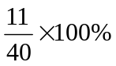
 | = 27.5%

 | Ans: |  |  |  | (c) | % | [1]
 |  | (d) |  | If a pie chart is drawn to represent the above data, find the angle of sector representing students whose masses are more than 45 kg and less than or equal to 55 kg.
Angle of sector | = 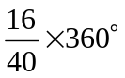
 | = 144°

 | Ans: |  |  |  | (d) | ° | [1]

End of Paper

