Candidate Name | Class | Register No

Geylang Methodist School (Secondary)

End-Of-Year Examination 2009

Mathematics  Paper 1 | Sec 1 Normal Academic
Additional Materials:  Nil | 1 hour  Oct 2009
Setter: Mr Wong Han Ming

READ THESE INSTRUCTIONS FIRST
Write in dark blue or black pen.

Do not use staples, paper clips, highlighters, glue or correction fluid.

Answer ALL Questions

If working is needed for any question, it must be shown below that question. Omission of working will result in the loss of marks.

Calculators are allowed in this paper.

If the degree of accuracy is not specified in the question, and if the answer is not exact, give the answer to 3 significant figures. Give answers in degrees to one decimal place.

INFORMATION FOR CANDIDATES
The number of marks is given in brackets [ ] at the end of each question or part question.
For Marker’s Use
This document consists of 11 printed pages.
[Turn Over]
Total Score: [50 marks]
Answer ALL questions in this paper.
All working must be shown in the space below the question.
Calculators ARE ALLOWED in this paper.

1. | (a) | Express 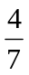 as a decimal, giving your answer to 3 decimal places.
 | (b) | Express 4.315 to 2 decimal places.
 | (c) | Express 538 250 to 3 significant figures.
 |  |  |  |  | Ans: |  | (a) | 0.571 |  | [1]
 |  |  |  |  |  |  | (b) | 4.32 |  | [1]
 |  |  |  |  |  |  | (c) | 538 000 |  | [1]
2. | Given that x = 3, y = 4 and z = −2, evaluate
 | (a) | 2x² − 5y + 3xz  (b) |  |  | 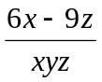  =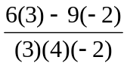  = 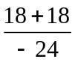  = −1.5
 | (b)
(a) | 2x² − 5y + 3xz  = 2(3)² − 5(4) + 3(3)( −2)  = 18 – 20 – 18  = −20
 |  |  |  |  | Ans: |  | (a) | −20 |  | [2]
 |  |  |  |  |  |  | (b) | −1.5 |  | [2]
3. | A sum of money is divided between Jacques, Ken and Lily in the ratio 5 : 7 : 10. Given that Ken received $5 more than Jacques, find the amount of money Lily received.
2 units → $5
10 units → 5 × 5 = $25

 |  |  |  |  | Ans: |  | $ 25 |  |  | [2]
4. | A pyramid is made of a square base and four identical triangular sides as shown below.
 |  |  |  |  | 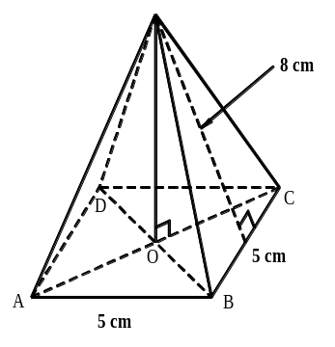
 | (a) | Draw the net of the pyramid in the answer space below, making sure your diagram is labelled with the respective lengths properly.
 | (b) | Calculate the total surface area of the whole pyramid.
Area of square
= 5 × 5
= 25 cm²

Area of 4 triangles
= 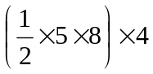
= 80 cm²

Total surface area
= 25 + 80
= 105 cm²

 | Ans: |  | (a)
 | 5 cm  5 cm  5 cm  5 cm  8 cm  8 cm |  |  |  |  |  |  |  |  | [2]
 |  |  |  |  |  |  | (b) | 105 cm² |  | [4]
5. | (a) | Express 3 375 as a product of prime factors, giving your answer in index notation.
 | (b) | Hence, showing your working very clearly, find the value of 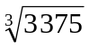 without using a calculator
3 | 3 375
3 | 1 125
3 | 375
5 | 125
5 | 25
5 | 5
 | 1

a) 3³ × 5³

b) 3 × 5 = 15

 |  |  |  |  | Ans: |  | (a) | 3³ × 5³ |  | [2]
 |  |  |  |  |  |  | (b) | 15 |  | [1]
6. | (a) | Find the highest common factor of 56 and 64.
 | (b) | Find the lowest common multiple of 18 and 24.
a)
2 | 56, 64
2 | 28, 32
2 | 14, 16
 | 7 , 8

H.C.F = 2 × 2 × 2
= 8

b)
2 | 18, 24
3 | 9, 12
 | 3, 4

L.C.M = 2 × 3 × 3 × 4
= 72

 |  |  |  |  | Ans: |  | (a) | 8 |  | [2]
 |  |  |  |  |  |  | (b) | 72 |  | [2]
7. | Express the following as a single fraction in its simplest form.
 | (a) | 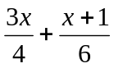
 | (b) | 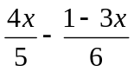
 | a)  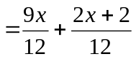  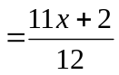 |  |  |  | b)  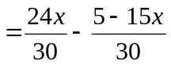  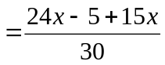  =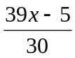
 |  |  |  |  | Ans: |  | (a) | 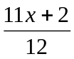 |  | [3]
 |  |  |  |  |  |  | (b) |  |  | [3]
8. | 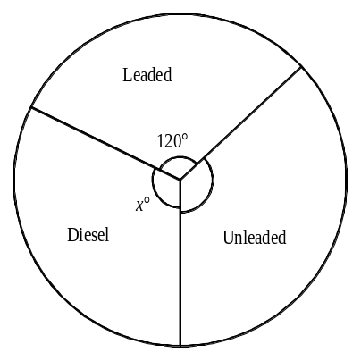A petrol station sells Unleaded fuel, Leaded fuel and Diesel fuel. The pie chart below represents the amounts of these fuels sold in one week.
 | (a) | Given that the total amount of fuel sold in a week is 51 000 litres, how many litres of Leaded fuel were sold?
 | (b) | If 17 850 litres of Diesel fuel were sold, find the value of x.
a) 360° → 51 000 l
120° → 51 000 ÷ 3
= 17 000 l

b) 51 000 l → 360°
17850 l → 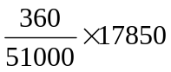

= 126°

 |  |  |  |  | Ans: |  | (a) | 17 000 litres |  | [2]
 |  |  |  |  |  |  | (b) | x = 126 |  | [2]
9. | (a) | In a restaurant, all prices were reduced by 35%. After the reduction, a set meal costs $35.75. What is the price of the set meal before the discount?
 | (b) | At a department store, a storewide sale of 30% was introduced in June. Ben bought a shirt for $16 at the store before the sale.
 |  | (i) |  | How much would the shirt cost during the sale?
 |  | (ii) |  | How much would he have saved if he had bought the shirt at the sale?
a) 65% → $35.75
100% → 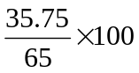 = $55

b)(i) $16 × 70% = $11.20

b)(ii) 16 – 11.20 = $4.80

 |  |  |  |  | Ans: |  | (a) | $ | 55 | [2]
 |  |  |  |  |  |  | (b) | (i) | $ 11.20 | [2]
 |  |  |  |  |  |  |  | (ii) | $ 4.80 | [1]
10. | Simplify the following completely.
 | (a) | 7a + 4b – 5a – b
 | (b) | 3(2a + b) + 5(a – b)
 | (c) | b(3a + 2) – 5a(4 – b)
a) 7a + 4b – 5a – b
= 2a + 3b

b) 3(2a + b) + 5(a – b)
= 6a + 3b + 5a – 5b
= 11a – 2b

c) b(3a + 2) – 5a(4 – b)
= 3ab + 2b – 20a + 5ab
= 8ab + 2b – 20a

 |  |  |  |  | Ans: |  | (a) | 2a + 3b |  | [2]
 |  |  |  |  |  |  | (b) | 11a – 2b |  | [2]
 |  |  |  |  |  |  | (c) | 8ab + 2b – 20a |  | [2]
11. | The figure below shows a triangle inside a semi-circle. Find the area of the shaded parts.  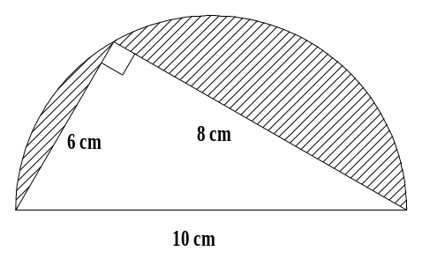Take π = 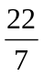 and leave your answer as a fraction or mixed number.
Area of semi circle
= πr²
= 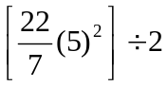
= 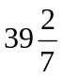 cm²

Area of triangle
= 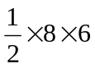
= 24 cm²

Shaded area
= 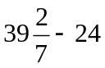
= 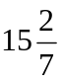 cm²

 |  |  |  |  | Ans: |  | cm² |  |  | [3]
12. | Town A and B are 250 km apart. Billy drives at an average speed of 40 km/h from Town A to B. After resting for 2 hours at Town B, he drives back to Town A at an average speed of 25 km/h.  Find
 | (a) | the total distance (in kilometers) travelled.
 | (b) | the total time taken (in hours) for the whole trip, including the resting time.
 | (c) | the average speed for the whole journey (in kilometers per hour), giving your answer to 3 significant figures.
a) 250 × 2 = 500 km

b) (250 ÷ 40) + 2 + (250 ÷ 25)
= 18.25 h

c) 500 ÷ 18.25 = 27.4 km/h

 |  |  |  |  | Ans: |  | (a) | 500km |  | [1]
 |  |  |  |  |  |  | (b) | 18.25 h |  | [2]
 |  |  |  |  |  |  | (c) | 27.4 km/h |  | [1]
End of Paper

Answers

1a 0.571
1b 4.32
1c 538 000

2a −20
2b −1.5

3 25

4a
5 cm
5 cm
5 cm
5 cm
8 cm
8 cm

4b 105

5a 3³ × 5³
5b 3 × 5 = 15

6a 8
6b 72

7a
7b

8a 17 000
8b 126

9a 55
9b(i) 11.20
9b(ii) 4.80

10a 2a + 3b
10b 11a – 2b
10c 8ab + 2b – 20a

11

12a 500
12b 18.25
12c 27.4

